**DAILY ONLINE ACTIVITIES SUMMARY**

|  |  |  |  |  |  |
| --- | --- | --- | --- | --- | --- |
| **Date:** | | **26/06/2020** | **Name:** | **JASLINE SHARON TAURO** | |
| **Sem & Sec** | | **4th sem, A Section** | **USN:** | **4AL18CS029** | |
| **Online Test Summary** | | | | | |
| **Subject** | **----** | | | | |
| **Max. Marks** | **----** | | **Score** | **----** | |
| **Certification Course Summary** | | | | | |
| **Course** | | DEVOPS ENGINEER | | | |
| **Certificate Provider** | | **AWS Educate** | **Duration** | | **4 hrs.** |
| **Coding Challenges** | | | | | |
| **Problem Statement:**  Given start and end of a range, write a Python program to print all negative numbers in given range. | | | | | |
| **Status: EXECUTED** | | | | | |
| **Uploaded the report in GitHub** | | | **YES** | | |
| **If yes Repository name** | | | <https://github.com/jaslinesharontauro/Python-coding> | | |
| **Uploaded the report in slack** | | | **YES** | | |

Online Test Details: (Attach the snapshot and briefly write the report for the same)

Certification Course Details: (Attach the snapshot and briefly write the report for the same)

Coding Challenges Details: (Attach the snapshot and briefly write the report for the same)

CERTIFICATION COURSE DETAILS:

## Today I have continued the course “DevOps Engineer” by AWS Educate. In this course today I learnt about ‘Introduction of DevOps and its Features and also about Platform Technologies of DevOps’. Today I have completed two modules of this course, And I have also completed the assessment of this module.

## 

## 

## 

WEBINAR DETAILS:

Today I have attended the webinar on “Cyber Security & Applications” by Professor Dr. Manjunath Kotari ,HOD CSE department- AIET. The session was very interesting. There were two assessments conducted based on the webinar. The tests were of MCQ type.

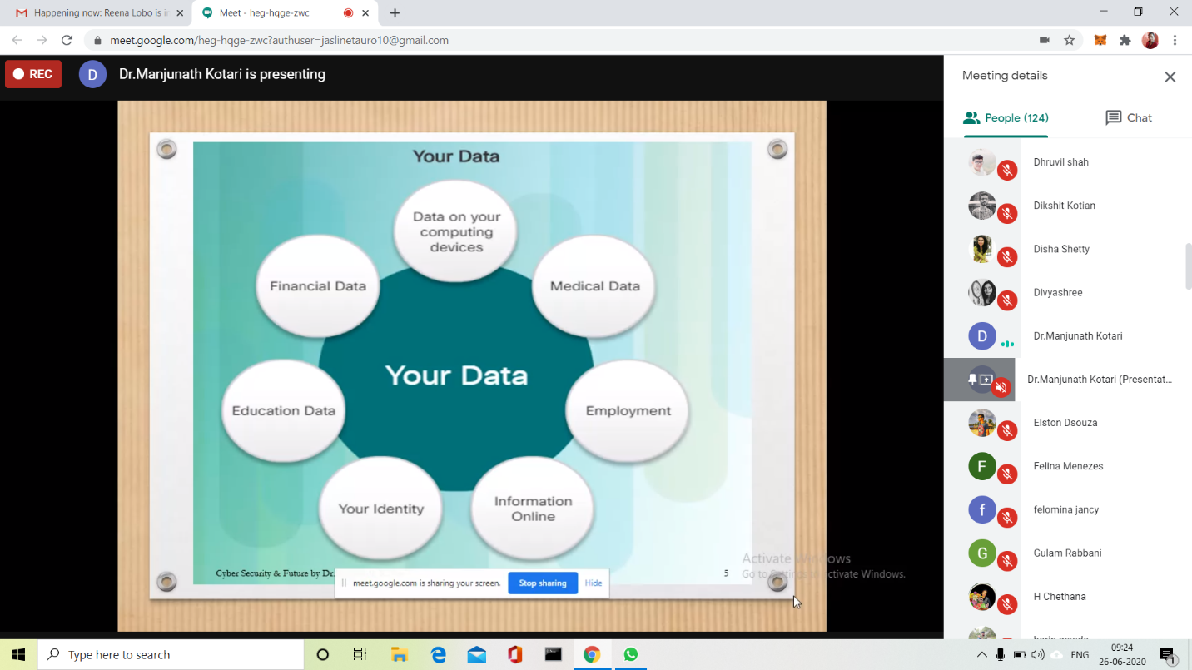

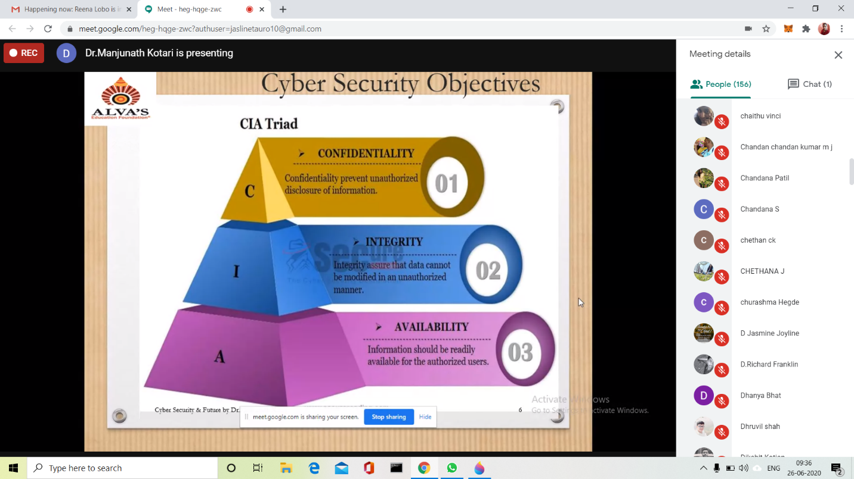



CODING CHALLENGES:

Problem Statement:

Given start and end of a range, write a Python program to print all negative numbers in given range.

Example: Input: start = -4, end = 5 Output: -4, -3, -2, -1

Input: start = -3, end = 4 Output: -3, -2, -1

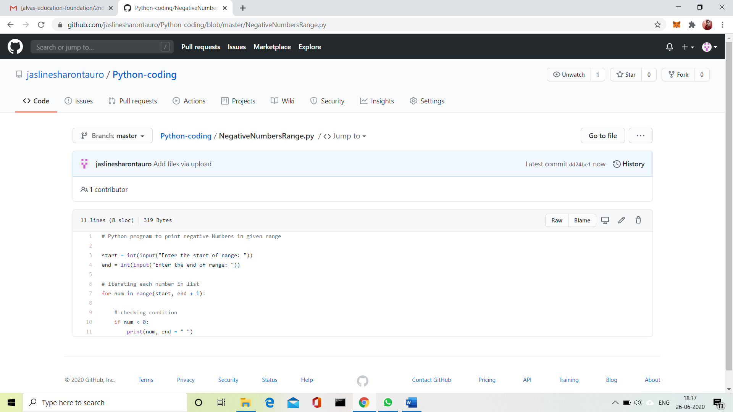

Solution Uploaded in GitHub.